Software Requirement Specification Document for Project GoodAct

By:
Raed Sherif, Ahmad Ehab, Anthony Edward, Mohamed Kilani, Seif Abdelkader.

Supervised by: Dr. Ayman Ezzat
ESLSCA University
School of Computing & Digital Technology

Tuesday the 2nd of June 2026



1 Introduction 2
1.1 Purpose of this document 2
1.2 Scope of this document 2
1.3 Overview 2
1.4 Business Context 2
2. General Description 3
2.1 Product Functions 3
2.2 Similar System information 3
2.3 User Characteristics 3
2.4 User Problem Statement 3
2.5 User Objectives 3
2.6 General Constraints 4
3. Functional Requirements 4
4 Interface Requirements 4
4.1 User Interface 4
5. Performance Requirements 5
6. Non Functional Requirements 5
7. Preliminary Object-Oriented Domain Analysis 5
7.1 Inheritance Relationships 5
7.2 Class descriptions 6
8. Operational Scenarios 8
10 References 13

1 Introduction

1.1 Purpose of this document
The goal is to clarify the specific technical (functional & non-functional) requirements in “GoodAct” a web application designed specifically as an online shopping platform featuring products and services with funds that are donated for good. This document is intended for stakeholders (developers and regulators) in this project.

1.2 Scope of this document
This document defines the requirements for the initial development phase.
- Development constrains:
- Schedule: Delivery deadline set on 2nd of June 2026.
- Technical Stack: PHP, HTML, CSS.
- Costs: None, only students’ time.

1.3 Overview
GoodAct is a community-driven platform which is designed to have some users list products and services and the money that is paid for such items or services will be given away as a donation for good.

1.4 Business Context
Mission Statement
Goodwill is a network of community-based organizations driven by a common mission to help people from all backgrounds reach their potential and thrive by building skills, earning jobs and advancing in their careers to achieve their own definition of success. Our trusted network of locally-led organizations advance these opportunities within their communities, sustainably funded through the sale of your donated goods.
Organizational Objectives
The primary goal is to establish a centralized platform that supports local communities and NGOs/NPOs

2. General Description

2.1 Product Functions
Core functions include role-based user authentication, product posting and editing by Providers, transaction processing for purchases of goods and services, and distinct, role-specific dashboard views. Which will be broken down in the next sub sections.

2.2 Similar System information
While the desired app possesses similarities with the likes of Goodwill. it’s a uniquely dedicated environment for fund-raising through acts of goods such as products re-sale and services.

2.3 User Characteristics
This section describes the features of the user community, including their expected expertise with software systems and the application domain.
- Sellers/Professionals: Expected to have high technical expertise but varying levels of professional domain experience.
- User: Expected to be someone who wants to make ethical purchase decisions to support local communities.
- Admins: Expected to have basic intermediate expertise moderating forums, interacting with systems and security best practices.

2.4 User Problem Statement
Local communities struggle to find funding and resources. While some professionals can not find resume-building opportunities. And some people want to receives services and goods but also know that their money is going to good places.

2.5 User Objectives
The system aims to provide a centralized hub where Individuals can find verified talent and contribute to the growth of the local economy and help fund good causes.

2.6 General Constraints
Hardware/Software Platforms
The application must be accessible via standard web browsers on consumer-grade hardware.
Structural Constraints: The data architecture must consist of a minimum of 7 entities. The system must successfully execute complete Create, Read, Update, and Delete (CRUD) operations across all of the entities.
Architectural Constraints: The backend design must adhere to Object-Oriented Programming (OOP) principles and follow MVC architecture, specifically requiring the implementation of at least one Interface class. And some design patterns.
Operational Constraints: The application must execute locally without containing any syntax errors or runtime bugs.

3. Functional Requirements
Functional requirements describe the possible effects of a software system, in other words, what the system must accomplish. All FR tables are in the functional requirement document found here:

https://docs.google.com/document/d/1YT7VJShveCjt0twpXbNPLcmpEsC6m_tEXP2HaYyCcZI/edit?usp=sharing

4 Interface Requirements

4.1 User Interface

GUI
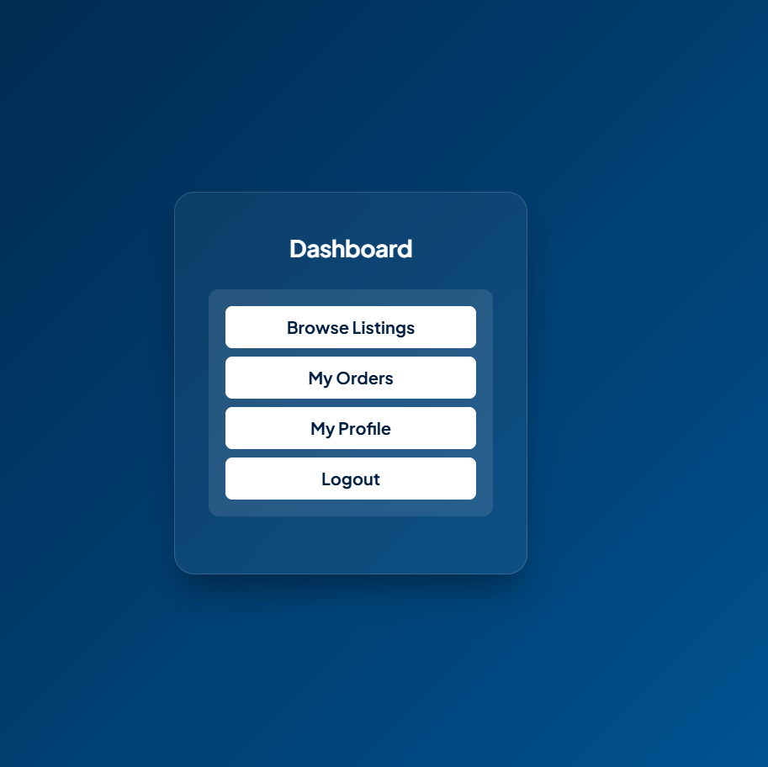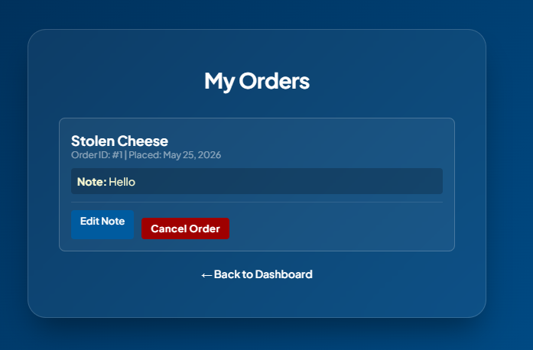

User view User Order form view
CLI
No CLI interactions.

API
No public API available.

Diagnostics or ROM
No Debugging log.

5. Performance Requirements
Since GoodAct is an academic project and will be evaluated on a local server, typical speed and memory requirements are out of scope. However, we aimed at keeping response time for all CRUD operations under 2 seconds and for all the php scripts and logic to be under 128MB as it's the default memory limit allocated by a standard local PHP installation.

6. Non Functional Requirements
The system non functional requirements such as security and usability are listed in great details in Non Functional Requirements document found at:
https://docs.google.com/document/d/1RjYmefZ0jN1rYOTraGSDlsADmYAMIqsGottEcGCUrYk/edit?usp=sharing

7. Preliminary Object-Oriented Domain Analysis
This section presents a list of the fundamental objects that must be modeled within the GoodAct system to satisfy its requirements. The purpose is to provide a structural view of how the system's backend will be developed in PHP.

7.1 Inheritance Relationships
This section illustrates the primary inheritance hierarchy (is-kind-of) for the system. To satisfy the diverse user roles required by the GoodAct platform, the system utilizes a parent User class that branches into specialized child actors, all of which implement a mandatory dashboard interface.

<<ADD UML HERE>>

7.2 Class descriptions
This section presents a more detailed description of each class identified during the OO Domain Analysis.
Interface name: DashboardUI
- Abstract or Concrete: Interface
- Purpose: A strict contract ensuring all user roles have a standardized method to render their specific dashboard views.
- Attributes: None
- Operations: * + generateDashboard(): string
Class name: User
- Abstract or Concrete: Abstract Parent Class
- Purpose: Serves as the foundational class handling shared identity and authentication logic. Maps to the users database table.
- Attributes: * - id: int
  - - roleId: int
  - - name: string
  - - email: string
  - - passwordHash: string
- Operations: * + login(email: string, password: string): boolean
  - + logout(): boolean
  - + signUp(name: string, email: string, password: string, roleId: int): boolean

Class name: NGO
- Abstract or Concrete: Concrete (Extends User)
- Purpose: Represents a verified non-profit organization. Maps to the ngo_profiles database table.
- Attributes: (Inherits all User attributes)
  - - licenseNumber: string
  - - missionStatement: string
- Operations: * + createProject(title: string, description: string, categoryId: int): boolean
  - + updateProject(projectId: int, title: string, description: string): boolean
  - + deleteProject(projectId: int): boolean
  - + reviewApplication(applicationId: int, status: string): boolean
  - + generateDashboard(): string

Class name: Student
- Abstract or Concrete: Concrete (Extends User)
- Purpose: Represents a volunteer seeking to apply technical skills to NGO projects.
- Attributes: (Inherits all User attributes)
  - - university: string
  - - major: string
- Operations: * + applyToProject(projectId: int): boolean
  - + submitReview(projectId: int, rating: int, comments: string): boolean
  - + generateDashboard(): string
Class name: Admin
- Abstract or Concrete: Concrete (Extends User)
- Purpose: A system administrator responsible for moderating the platform.
- Attributes: (Inherits all User attributes)
  - - adminLevel: int
- Operations: * + manageUsers(): boolean
  - + verifyNGO(ngoId: int): boolean
  - + generateDashboard(): string
Class name: Project
- Abstract or Concrete: Concrete
- Purpose: Represents a volunteer opportunity posted by an NGO. Maps to the projects database table.
- Attributes: * - projectId: int
  - - ngoId: int
  - - categoryId: int
  - - title: string
  - - description: string
  - - status: string
- Operations: * + create(ngoId: int, title: string, description: string, categoryId: int): boolean
  - + updateStatus(newStatus: string): boolean
  - + getDetails(): array
Class name: Application
- Abstract or Concrete: Concrete
- Purpose: The bridge entity linking a Student to a specific Project. Maps to the applications database table.
- Attributes: * - applicationId: int
  - - projectId: int
  - - studentId: int
  - - status: string
- Operations: * + submit(projectId: int, studentId: int): boolean
  - + updateStatus(newStatus: string): boolean
Class name: Review
- Abstract or Concrete: Concrete
- Purpose: Structured feedback provided by a Student after completing a Project. Maps to the reviews database table.
- Attributes: * - reviewId: int
  - - projectId: int
  - - reviewerId: int
  - - rating: int
  - - comments: string
- Operations: * + submit(projectId: int, reviewerId: int, rating: int, comments: string): boolean

8. Operational Scenarios
This section provides a step-by-step script of a primary system transaction, mapping the user's interaction from the GUI layer down to the Object-Oriented backend and database execution.

Scenario A: A Student applies to an open NGO volunteer project. Primary Actor: Student (Authenticated) Preconditions: The system recognizes the active $_SESSION as a 'Student'. The Student is currently viewing the details page of an open Project.

Step | Actor Action | System / Backend Response
1 | The Student clicks the "Apply Now" button on the project posting. | The browser sends an HTTP POST request to the application router containing the specific projectId.
2 |  | The Router directs the request to the appropriate controller (e.g., ApplicationController).
3 |  | The Controller verifies the $_SESSION['roleId'] corresponds to a Student to enforce backend security constraints.
4 |  | The Controller instantiates the Student model and calls the applyToProject(projectId: int) method, passing the session's user ID and the requested project ID.
5 |  | The Student model formulates a parameterized SQL INSERT statement to add a new record to the applications database table with a default status of 'Pending'.
6 |  | The Database executes the query. Upon successful insertion, the model returns a boolean value of true back to the Controller.
7 |  | The Controller receives the true boolean and triggers a UI update, changing the button state to "Application Submitted" and rendering a success message via the DashboardUI.

Postconditions: A new record exists in the applications database table linking the studentId to the projectId. The NGO will now see this student in their application review queue.

Scenario B: An NGO posts a new volunteer project. Primary Actor: NGO (Authenticated) Preconditions: The system recognizes the active $_SESSION as an 'NGO'. The NGO is on the "Create Project" dashboard view.

Step | Actor Action | System / Backend Response
1 | The NGO fills out the project details form (Title, Description, Category) and clicks "Publish". | The browser sends an HTTP POST request to the router containing the form data.
2 |  | The Router directs the request to the ProjectController.
3 |  | The Controller verifies the $_SESSION['roleId'] corresponds to an NGO to prevent unauthorized users from posting.
4 |  | The Controller instantiates the NGO model and calls the createProject(title, description, categoryId) method, passing the sanitized form data and the session's userId.
5 |  | The NGO model validates the NGO's licenseNumber and formulates an INSERT INTO projects SQL statement.
6 |  | The Database executes the query. Upon success, the model returns true to the Controller.
7 |  | The Controller triggers a redirect back to the DashboardUI, which now queries and renders the newly created project in the NGO's active list.

Scenario C: An Admin removes a user account that violates platform rules. Primary Actor: Admin (Authenticated) Preconditions: The system recognizes the active $_SESSION as an 'Admin'. The Admin is viewing the centralized user management table.
Step | Actor Action | System / Backend Response
1 | The Admin clicks the "Delete Account" button next to a specific user's row. | The browser sends an HTTP POST request to the router containing the target userId and a delete action flag.
2 |  | The Router directs the request to the AdminController.
3 |  | The Controller strictly verifies the $_SESSION['roleId'] corresponds to an Admin.
4 |  | The Controller instantiates the Admin model and calls the manageUsers() method, passing the target userId and the delete command.
5 |  | The Admin model formulates a DELETE FROM users WHERE id = ? SQL statement.
6 |  | The Database executes the query. Because of the ON DELETE CASCADE constraint in the schema, all associated projects or applications tied to that user are also cleanly removed. The model returns true.
7 |  | The Controller receives the success boolean and re-renders the DashboardUI with an updated, fresh list of users.

10 References
The following resources, tools, and documentation were consulted during the design and development of the PushForGood platform:
- PHP Documentation: Official PHP manual for vanilla backend logic and PDO database connections. (Available at: php.net)
- MySQL Documentation: Official reference for relational database design and SQL syntax. (Available at: dev.mysql.com/doc/)
- Apache Friends (XAMPP): Used for configuring the local Apache web server and MariaDB/MySQL environment. (Available at: apachefriends.org)
- Material Design Guidelines: Consulted for standardizing GUI elements, button states, and form inputs. (Available at: material.io)
- Color Hunt: Utilized for selecting the standardized frontend color palette. (Available at: colorhunt.co)
- UML Standards: Unified Modeling Language conventions used for drafting the Object-Oriented Domain Analysis and Use Case diagrams

